Spring Boot Web Project

Project Name: spring-learn
Technology Used: Spring Boot, Maven

Objective:
To create a Spring Boot web project using Maven, explore its structure, configure logging, and run the application successfully.

🔧 Steps Followed:
1. Project Initialization
- Used https://start.spring.io with the following configuration:
  - Group: com.cognizant
  - Artifact: spring-learn
  - Dependencies: Spring Web, Spring Boot DevTools
- Extracted the ZIP to Eclipse workspace.
2. Importing into Eclipse
- Followed:
- File > Import > Maven > Existing Maven Projects
- Selected the extracted folder and finished importing.
3. Building the Project
- Ran the Maven build command:

PS C:\Users\chait\eclipse-workspace\spring-learn> mvn clean package

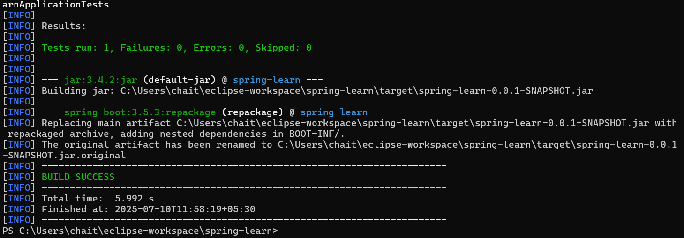

4. Application Code Setup
- Located SpringLearnApplication.java inside:
- src/main/java/com/cognizant/spring_learn/

SpringLearningApplication.java:

package com.cognizant.spring_learn;

import org.slf4j.Logger;
import org.slf4j.LoggerFactory;
import org.springframework.boot.SpringApplication;
import org.springframework.boot.autoconfigure.SpringBootApplication;

@SpringBootApplication
public class SpringLearnApplication {

public static final Logger log = LoggerFactory.getLogger(SpringLearnApplication.class);
public static void main(String[] args) {
SpringApplication.run(SpringLearnApplication.class, args);

log.info("Main Program Executed");
}

}

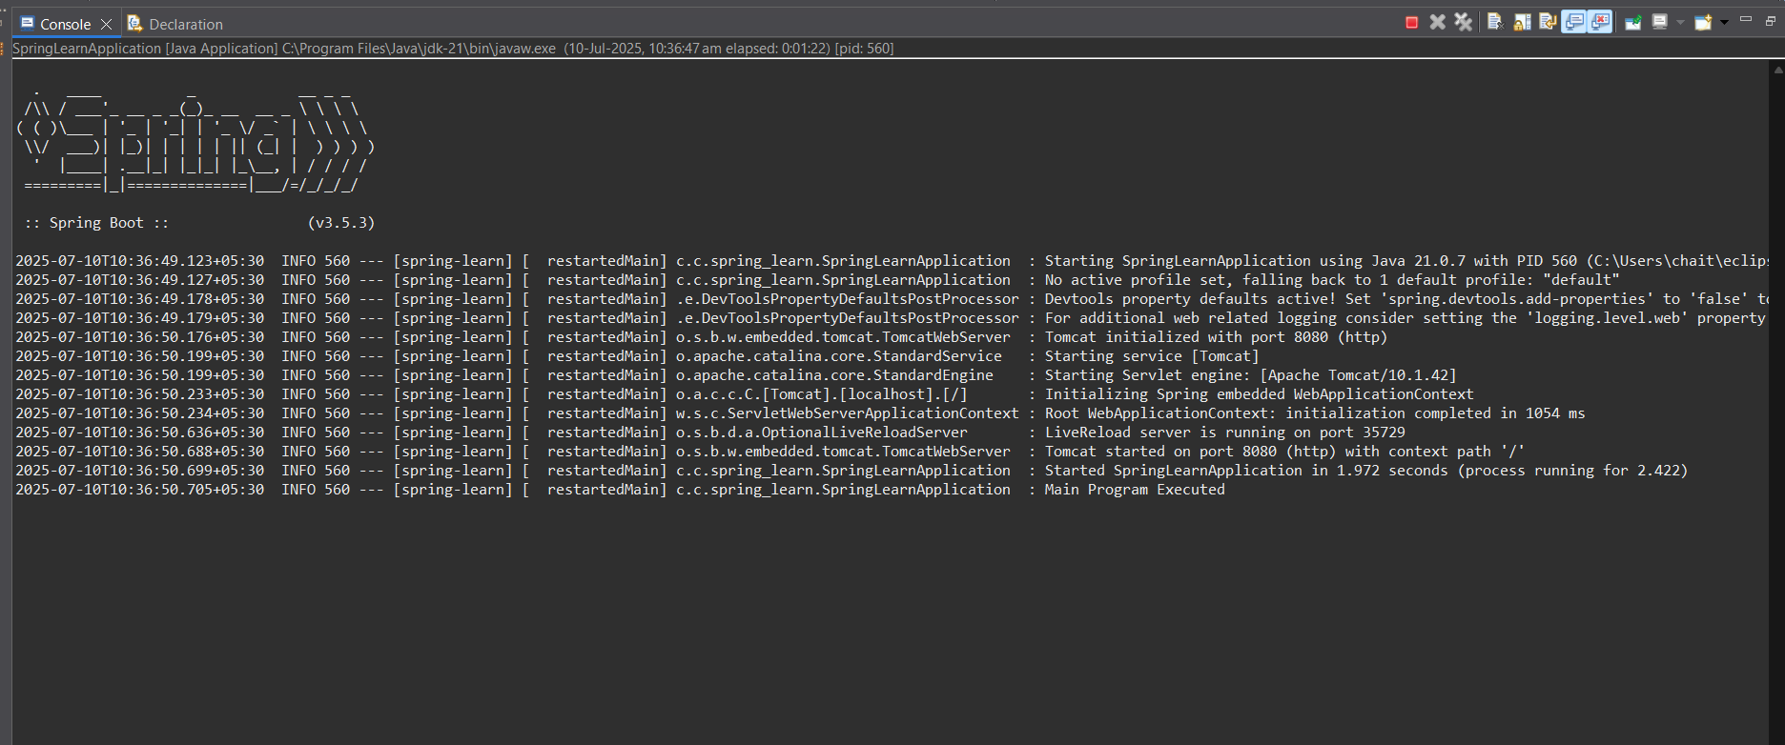
vvhshsjhj 5. CONSOLE :

🗂 Project Structure Overview:
Folder / File | Purpose
src/main/java | Application source code
src/main/resources | Configuration files (e.g., application.properties)
src/test/java | Placeholder for test classes
pom.xml | Maven build configuration

🔍 Maven Dependency Hierarchy:

PS C:\Users\chait\eclipse-workspace\spring-learn> mvn dependency:tree

